3) Create a simple cloud software application for Property Buying & Rental process (In

Chennai city) using any Cloud Service Provider to demonstrate SaaS

#CREATING THE CUSTOMER DETAILS

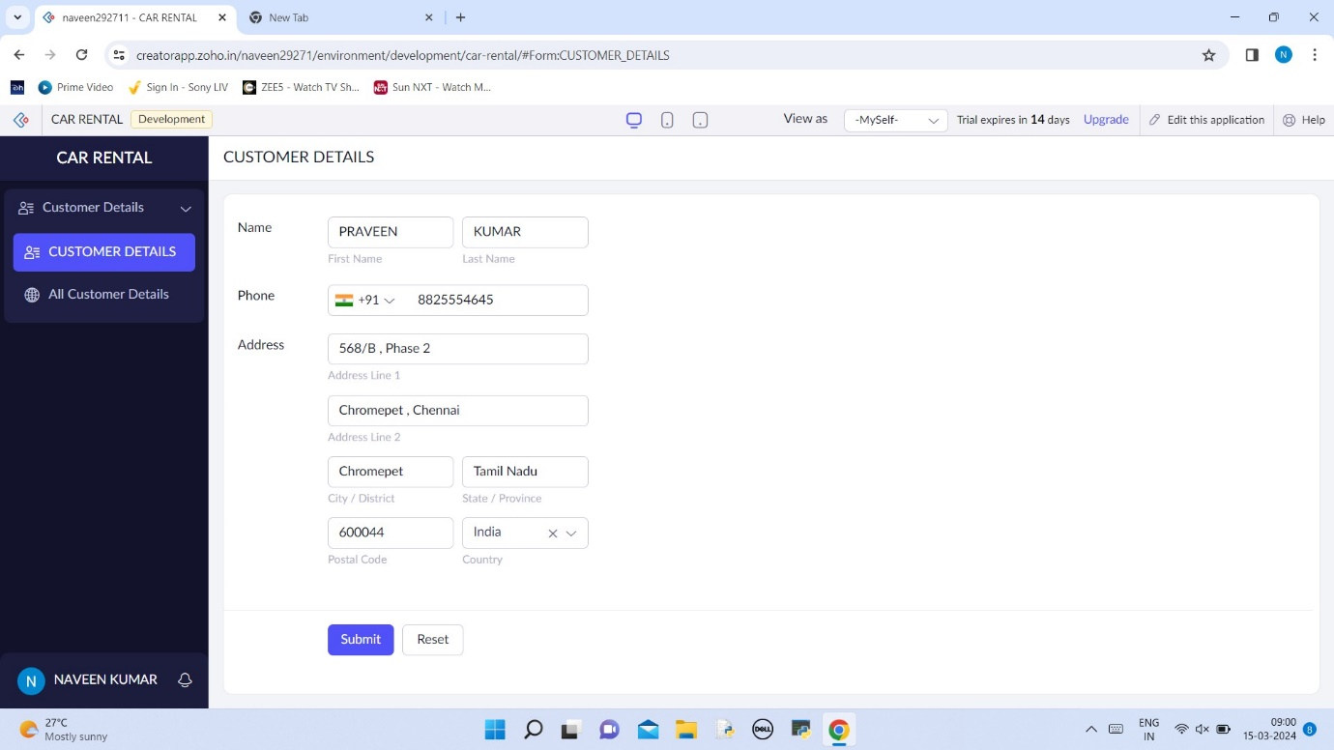

# ALL CUSTOMER DETAILS HAS BEEN DISPLAYED

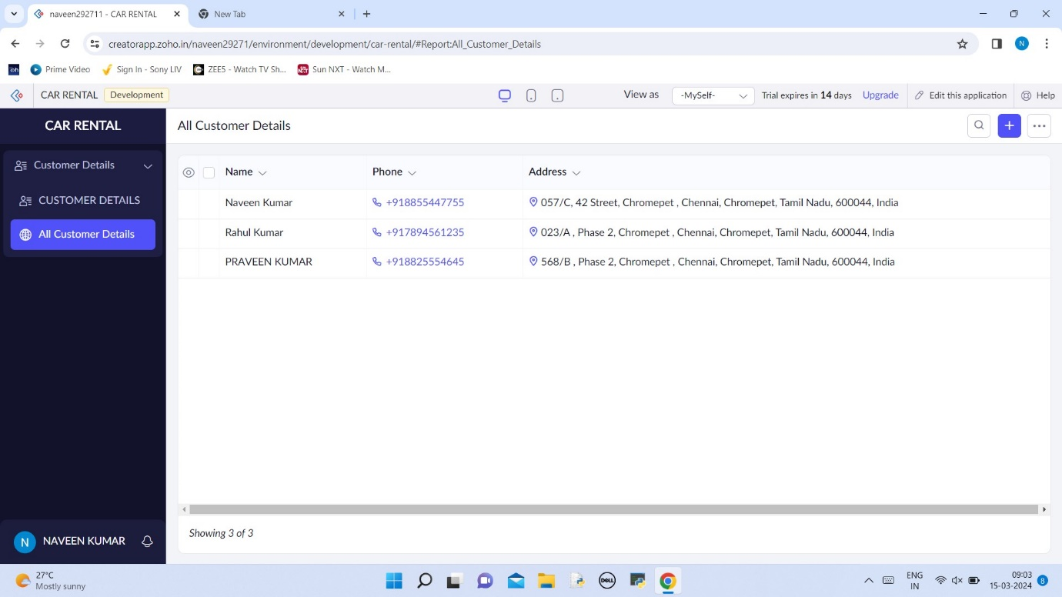

# CREATE A CAR BOOKING DETAILS

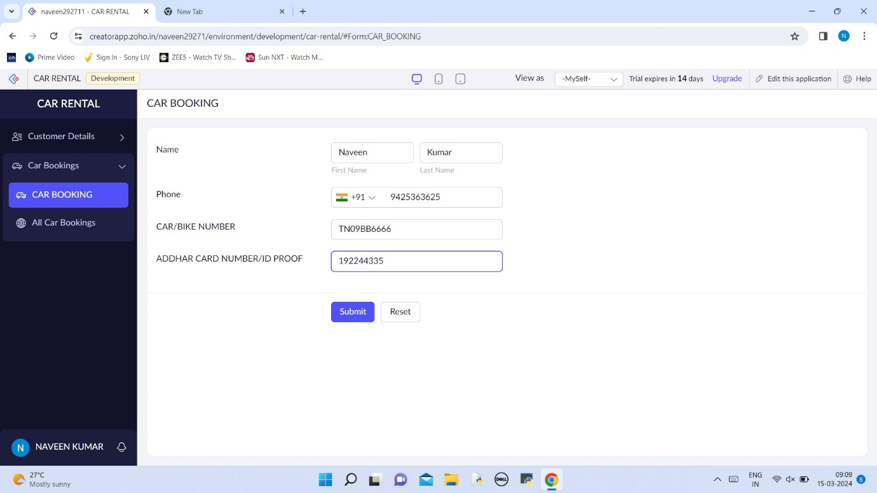

# DISPLAYING THE DETAILS OF CAR BOOKED PERSON

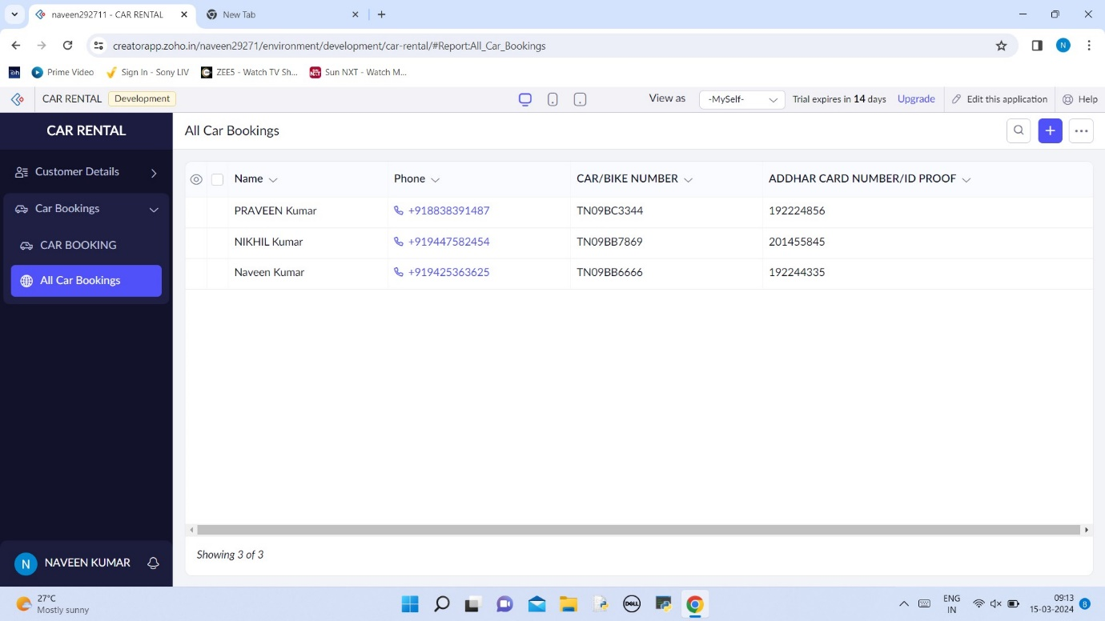

# CREATING THE PAYMENT METHOD

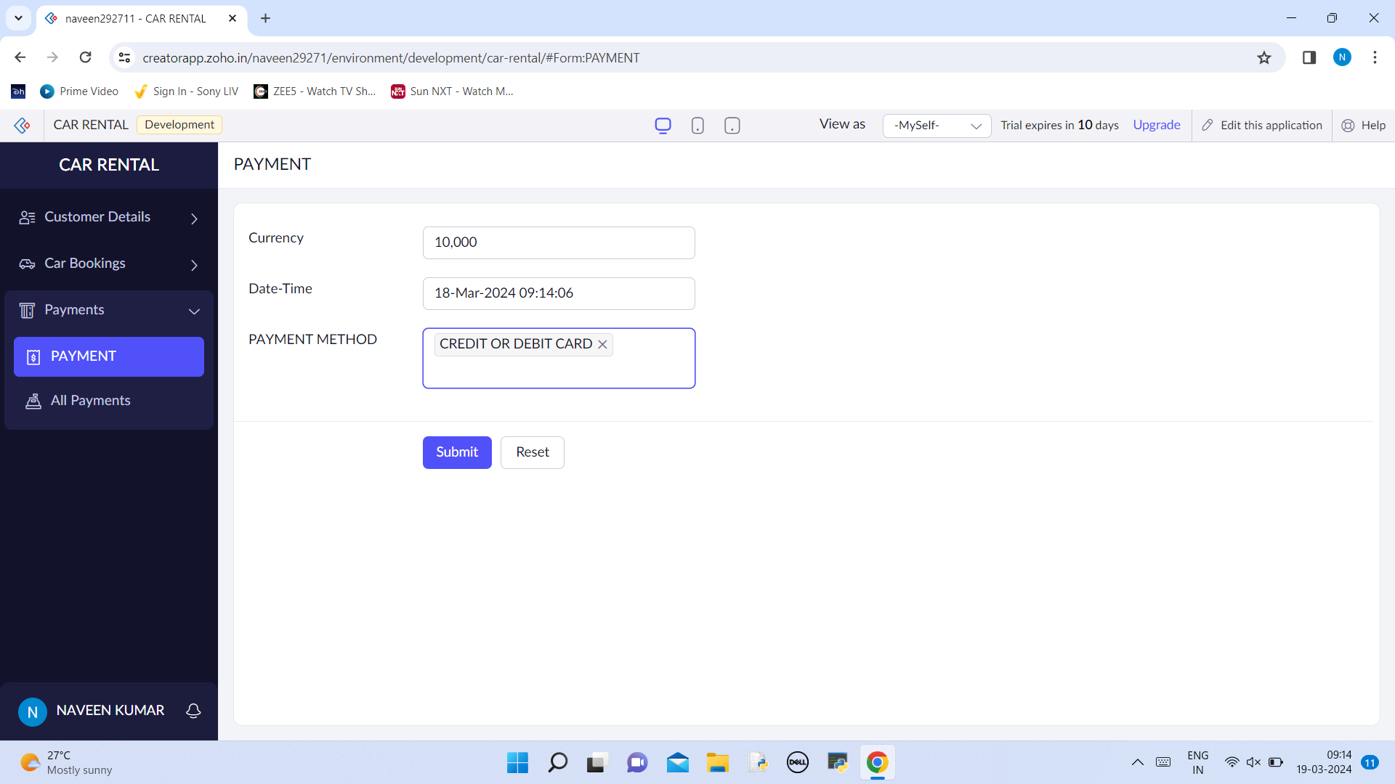

# DISPLAYING THE PAYMENT METHOD SELECTED

